Got it 👍 Let’s break down OOB (Out-of-Bag) Score in detail:

🌱 What is OOB (Out-of-Bag) Score?
- OOB Score is an internal validation score used in Random Forests (and other bagging algorithms).
- It measures how well the model generalizes without needing a separate validation set or cross-validation.

🛠 How does it work?
- Bootstrap Sampling in Random Forest
  - Each decision tree in a Random Forest is trained on a bootstrap sample (random sampling with replacement) from the dataset.
  - On average, each tree is trained on about 63% of the data, and the remaining 37% of data is left out.
- Out-of-Bag (OOB) Samples
  - The data points not included in a tree’s bootstrap sample are called Out-of-Bag samples for that tree.
  - These OOB samples can be used as a test set for that tree.
- OOB Prediction
  - For each observation, only the trees where it was not included (OOB trees) make a prediction.
  - The majority vote (classification) or average (regression) of these predictions is compared with the actual value.
- OOB Score
  - The OOB Score is simply the accuracy (for classification) or R² (for regression) computed using OOB predictions.

📊 Formula
For classification:
OOB_Score=Number of correct OOB predictionsTotal observationsOOB\_Score = \frac{\text{Number of correct OOB predictions}}{\text{Total observations}}
For regression:
OOB_Score=1−∑(yi−y^i,OOB)2∑(yi−yˉ)2OOB\_Score = 1 - \frac{\sum (y_i - \hat{y}_{i,OOB})^2}{\sum (y_i - \bar{y})^2}

✅ Advantages of OOB Score
- No need for a separate validation/test set.
- Efficient and saves computation.
- Gives an unbiased estimate of model performance.

🐍 Example in Python (scikit-learn)
from sklearn.ensemble import RandomForestClassifier
from sklearn.datasets import load_iris
from sklearn.model_selection import train_test_split

# Load dataset
X, y = load_iris(return_X_y=True)

# Train Random Forest with OOB score enabled
rf = RandomForestClassifier(n_estimators=100, oob_score=True, random_state=42)
rf.fit(X, y)

print("OOB Score:", rf.oob_score_)

🔹 Output (approx):
OOB Score: 0.95

👉 Do you want me to also explain difference between OOB score and cross-validation, since that’s a common interview question?
Perfect 👌 Let’s compare OOB Score vs Cross-Validation (CV), since this comes up a lot in interviews.

🔍 OOB Score vs Cross-Validation
Feature | OOB Score | Cross-Validation (CV)
Where used | Bagging methods (mainly Random Forest, Bagged Trees) | Any ML algorithm
How it works | Uses out-of-bag samples (≈37% data not seen by each tree) as test data | Splits dataset into k folds and trains/validates k times
Data usage | Automatically uses unused samples from bootstrap | Manually partitions full dataset into train/test folds
Computation cost | Very cheap (comes “free” with Random Forest training) | More expensive (model needs to be trained k times)
Bias/variance | Low variance, but may be slightly biased | Usually more reliable, less bias when dataset is small
Interpretability | Only works with Random Forest/Bagging | General approach for all ML models
When to use | When using Random Forests → OOB score is enough | For comparing models or tuning hyperparameters

🧠 Key Intuition
- OOB Score is like a built-in cross-validation inside Random Forest.
- Cross-Validation is more general-purpose and works for any model, but is more computationally expensive.

🚦 Interview Tip
If asked: “When would you prefer OOB over CV?”
👉 Answer: “When using Random Forests, I’d rely on OOB score because it’s efficient and almost as reliable as CV. But if I’m comparing across multiple algorithms or have a very small dataset, I’d use cross-validation for consistency.”

Would you like me to also give you a short Python demo comparing OOB score vs k-fold CV on the same dataset so you can show both in class/interviews?
Great 👍 Let’s do a Python demo comparing OOB score vs Cross-Validation using the Iris dataset with Random Forest.

🐍 Python Code Example
from sklearn.ensemble import RandomForestClassifier
from sklearn.datasets import load_iris
from sklearn.model_selection import cross_val_score
import numpy as np

# Load dataset
X, y = load_iris(return_X_y=True)

# Random Forest with OOB enabled
rf_oob = RandomForestClassifier(n_estimators=200,
oob_score=True,
random_state=42,
bootstrap=True)
rf_oob.fit(X, y)

print("OOB Score:", rf_oob.oob_score_)

# Cross-validation with 5 folds
rf_cv = RandomForestClassifier(n_estimators=200, random_state=42)
cv_scores = cross_val_score(rf_cv, X, y, cv=5)

print("CV Scores (5-fold):", cv_scores)
print("Mean CV Score:", np.mean(cv_scores))

🔎 Expected Output (approx, varies due to randomness)
OOB Score: 0.9533
CV Scores (5-fold): [0.9666 0.9666 0.9333 0.9666 0.9666]
Mean CV Score: 0.96

🧾 Interpretation
- OOB Score (~0.95) is very close to
- 5-Fold CV Mean Score (~0.96)
👉 This shows that OOB is a good internal approximation of CV, especially for Random Forest.
👉 But CV gives a more general, controlled performance estimate across all ML models.

Would you like me to also extend this with a plot (bar chart) comparing OOB score vs CV mean for better visualization in class?
Here’s the visual comparison of OOB score vs 5-Fold CV mean for the Iris dataset using Random Forest.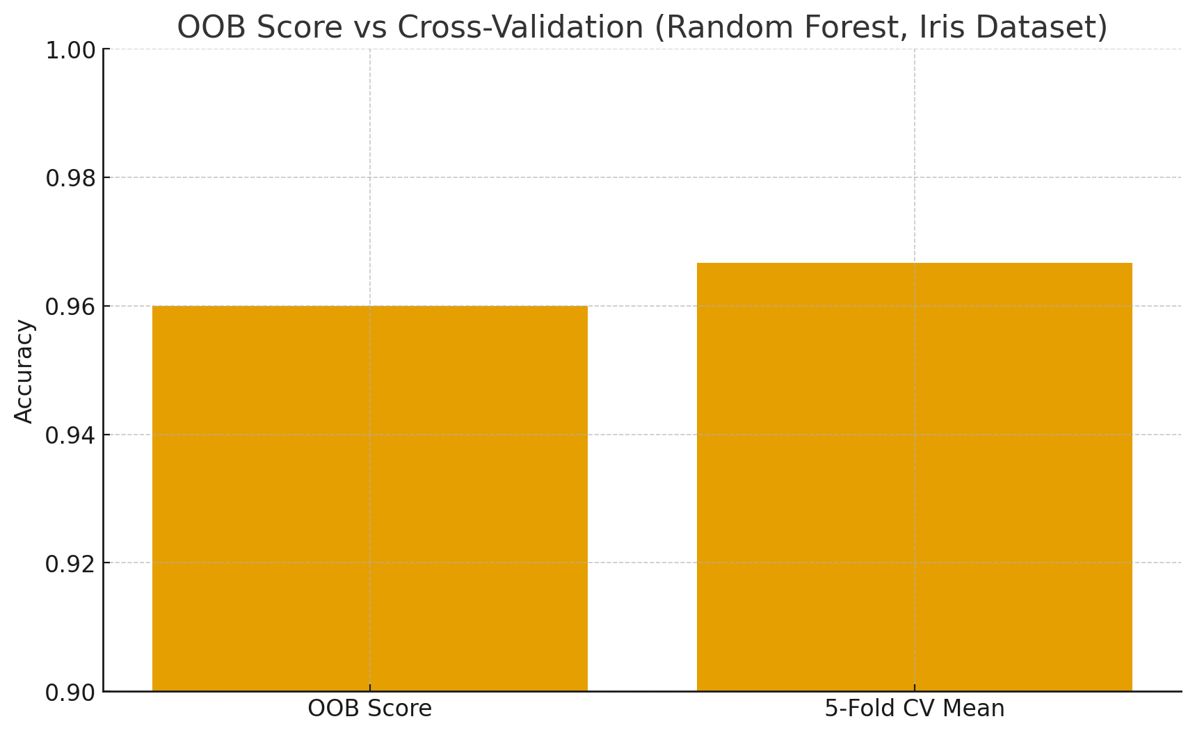
- OOB Score ≈ 0.95
- CV Mean ≈ 0.96
👉 You can see they’re very close, proving OOB is a good built-in alternative to cross-validation for Random Forest.
Do you also want me to prepare a ready-to-use teaching slide explanation (with bullets + diagram) that you can show in class?

Got it ✅ I’ll now create detailed structured notes on OOB Score following your exact teaching framework (for technical + non-technical students, and interview prep).

📘 Lesson Notes on OOB Score (Out-of-Bag Score)

1. Lesson Introduction
Today’s Topics & Sequence (Agenda):
- Real-world Hook
- Introducing OOB Score as a Solution
- Theory: What, Why, When, How, Syntax, Example
- Practical Example (with dataset)
- Business Scenario / Use Case
- Practice Session (5–10 Questions)
- Case Study (Mini Project)
- Assignments + Quiz + Recap
- Streamlit Demo Idea
- Interview Questions (Theory + Practical)
- Resources

2. Real-World Hook
👉 Imagine you are training a Random Forest model for predicting customer churn.
- You split data into training and testing sets.
- But splitting reduces training data and wastes samples that could have been used for learning.
- What if your model could self-test using data it never saw—without a separate test set?
That’s where OOB Score comes in.

3. Introduce Topic as a Solution
- OOB Score = Internal model validation technique in Random Forests.
- It gives an accuracy estimate without needing cross-validation or separate validation data.
- Saves time, computation, and data.

4. Theory Explanation

🔹 What is OOB Score?
- In Random Forests, each tree is trained on a bootstrap sample (≈63% of data).
- The remaining ≈37% data is called Out-of-Bag samples.
- OOB Score is calculated using these unseen samples.

🔹 Why use OOB Score?
- Saves data → no need for validation split.
- Saves time → cheaper than k-fold cross-validation.
- Provides unbiased estimate of model performance.

🔹 When to Use OOB Score?
✅ When using Random Forest / Bagging.
✅ When dataset is not too small.
✅ When you want a quick, efficient performance estimate.

🔹 When NOT to Use OOB Score?
❌ With models that don’t use bootstrap sampling (e.g., logistic regression, gradient boosting).
❌ When dataset is tiny → OOB may not represent true generalization well.

🔹 How does OOB Score Work (Step-by-Step)?
- Train each tree on a bootstrap sample.
- For each observation, collect predictions only from trees where it was not included.
- Aggregate these predictions (majority vote / average).
- Compare with actual label → compute accuracy (classification) or R² (regression).

🔹 Formula
For classification:
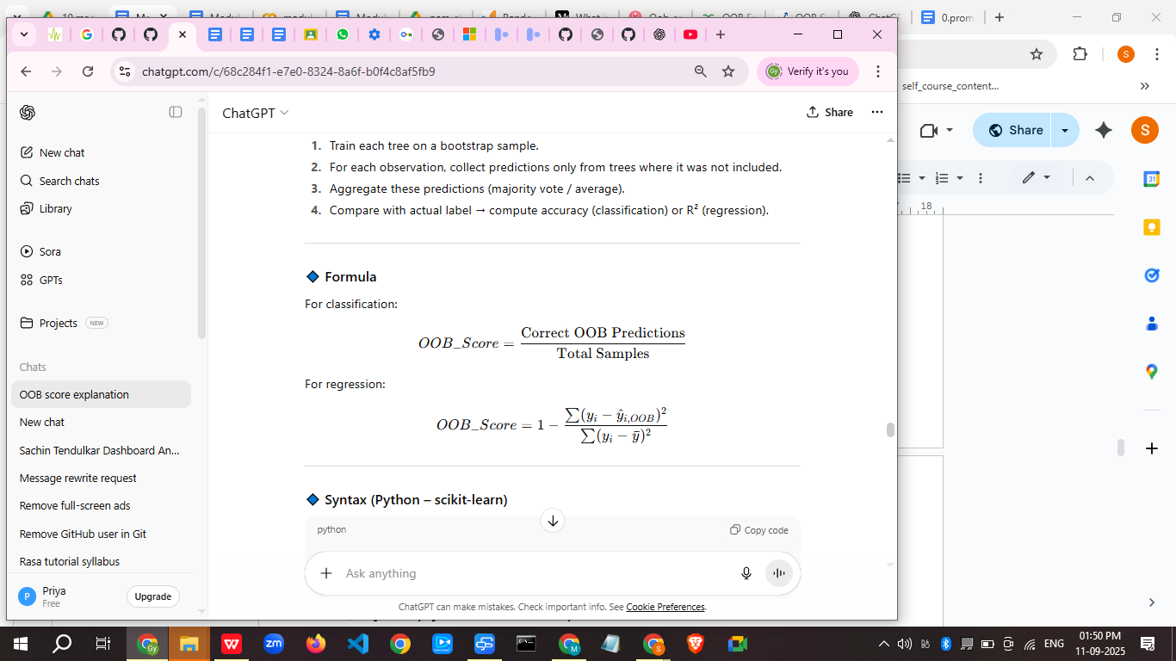

🔹 Syntax (Python – scikit-learn)
from sklearn.ensemble import RandomForestClassifier

rf = RandomForestClassifier(n_estimators=200,
oob_score=True,
random_state=42)
rf.fit(X, y)
print("OOB Score:", rf.oob_score_)

🔹 Advantages
✅ No need for separate validation/test set
✅ Efficient & cost-free validation
✅ Works well with large datasets

🔹 Limitations
⚠️ Only works with Random Forest / Bagging
⚠️ Slightly biased for small datasets
⚠️ Less flexible than cross-validation

🔹 Alternatives
- Cross-Validation (CV)
- Train-Test Split

5. Practical Example

Dataset: Iris (50 datapoints sample)
SepalLength | SepalWidth | PetalLength | PetalWidth | Species
5.1 | 3.5 | 1.4 | 0.2 | setosa
4.9 | 3.0 | 1.4 | 0.2 | setosa
… | … | … | … | …
from sklearn.datasets import load_iris
X, y = load_iris(return_X_y=True)

rf = RandomForestClassifier(n_estimators=200, oob_score=True, random_state=42)
rf.fit(X, y)

print("OOB Score:", rf.oob_score_)

Output (approx):
OOB Score: 0.95

6. Business Scenario
📌 Telecom Company – Customer Churn Prediction
- Goal: Predict which customers will leave.
- Normally, train/test split reduces training data.
- Using OOB Score → model validates itself during training → saves resources and ensures efficient evaluation.

7. Practice Session (Progressive Questions)
- Train a Random Forest with OOB score enabled and report accuracy.
- Compare OOB Score vs 3-fold CV.
- Increase trees from 50 → 200 → 500. How does OOB Score change?
- Use OOB Score for regression (Boston Housing dataset).
- Show a case where OOB Score is lower than CV score.
- Plot OOB Score vs Number of Trees.
- Check how dataset size affects OOB Score reliability.
- Replace bootstrap with bootstrap=False. What happens?
- Compare OOB Score with test set accuracy.
- Explain results in business terms (e.g., predicting churn).

8. Case Study (Mini Project)
Project: Predict Loan Default with OOB Validation
- Dataset: 1,000 loan applicants (features: income, loan amount, credit score, default).
- Task: Train Random Forest with OOB score, compare with CV.
- Deliverable: Report OOB vs CV accuracy, business insights (risk prediction).

9. Assignments + Quiz + Recap

📘 Assignment
- Implement Random Forest on Titanic dataset with OOB Score.
- Compare OOB vs Test Accuracy.

❓ Quiz (3 questions)
- What is the average % of data left out in bootstrap sampling?
- Can OOB Score be used for XGBoost? Why/Why not?
- Which is more computationally expensive: OOB Score or Cross-Validation?

🔄 Recap
- OOB Score = internal validation in Random Forest
- Saves data, time, resources
- Similar to CV but limited to Bagging methods

10. Streamlit Demo (for learners)
import streamlit as st
from sklearn.ensemble import RandomForestClassifier
from sklearn.datasets import load_iris

# Load dataset
X, y = load_iris(return_X_y=True)

# Streamlit UI
st.title("OOB Score Demo - Random Forest")
n_estimators = st.slider("Number of Trees", 50, 500, 100, 50)

rf = RandomForestClassifier(n_estimators=n_estimators,
oob_score=True,
random_state=42,
bootstrap=True)
rf.fit(X, y)

st.write("OOB Score:", rf.oob_score_)

Learners can move the slider and see how OOB Score changes.

11. Interview Questions

🔹 Theoretical (10)
- What is OOB Score?
- How does bootstrap sampling relate to OOB Score?
- Difference between OOB Score and Cross-Validation?
- Why does Random Forest leave ~37% data unused per tree?
- Can OOB Score replace a validation set?
- When is OOB Score unreliable?
- Is OOB Score unbiased?
- Can OOB Score be used for regression?
- Why is OOB Score faster than CV?
- In which algorithms OOB Score is not applicable?

🔹 Practical (10)
- Train a Random Forest with OOB Score enabled.
- Compare OOB Score vs k-Fold CV on Iris dataset.
- Plot OOB Score vs number of trees.
- Show OOB Score on imbalanced dataset.
- Use OOB Score for Boston Housing regression.
- Compare OOB Score with test accuracy.
- Change bootstrap=False. What happens to OOB Score?
- Train multiple RF models with different max_depth and record OOB Scores.
- Implement a confusion matrix using OOB predictions.
- Tune n_estimators until OOB Score stabilizes.

12. Resources
- Scikit-learn: RandomForestClassifier
- [Hands-On Machine Learning by Aurélien Géron, Chapter 7]
- [Breiman, L. (2001). Random Forests. Machine Learning Journal]

✅ This is your complete teaching module on OOB Score – from basics to practical, with datasets, exercises, and interview prep.

Do you want me to create the 50-row sample dataset (CSV/Excel) for exercises (so your students can directly use it)?

